
School: ............................................................................................................. Campus: ....................................................... Academic Year: ...................... Subject Name: ........................................................... Subject Code: ..........................
Semester: ............... Program: ........................................ Branch: ......................... Specialization: .......................... Date: .....................................
(Learning by Doing and Discovery)
* Coding Phase: Pseudo Code / Flow Chart / Algorithm
Process for Dissecting a Transaction :
- Collect Your Transaction:
- Open your Solidity IDE
- Create your file
- Open the connected MetaMask Browser
- On your MetaMask, select a network i.e Ethereum Sepolia
- Copy your MetaMask address or Your Public Key.
- In another browser search for Ethereum Sepolia faucet.
- Select Network (Ethereum Sepolia)
- Paste your public key in wallet Address
- Click on Receive Sepolia.
- Dissect Your Transaction:
- Write contract in the Remix IDE
- Compile it
- Change Deploy & Run Transaction→ Environment →Injected Provider MetaMask
- Then Deploy it.

Coding Phase: Pseudo Code / Flow Chart / Algorithm
In MetaMask:
Dissecting means:
- Before sending – Checking:
  - From / To address
  - Network (Ethereum mainnet, Sepolia, etc.)
  - Gas fee (max fee per gas, gas limit)
  - Transaction type (simple ETH transfer, contract call, token transfer)
  - Data field (if it’s calling a smart contract)
- After sending – Opening the transaction in a block explorer (like Etherscan) to see:
  - Transaction hash (unique ID)
  - Block number
  - Status (success or failed)
  - Gas used
  - Events / Logs (emitted by the smart contract)
  - Value transferred and function executed

In Remix IDE :
When you run a transaction (e.g., calling a smart contract function),
Remix shows:
- Transaction cost (in gas and ETH)
- Execution cost (gas used without deployment overhead)
- Decoded input (function name & parameters)
- Decoded output (return values)
- Logs (events emitted by the smart contract)
- Debugging tab – lets you step through opcodes and storage changes
This is like doing a microscopic forensic check on what your smart contract actually did on-chain.

* Softwares used
- Remix IDE
- MetaMask Wallet

- Testing Phase: Compilation of Code (error detection)
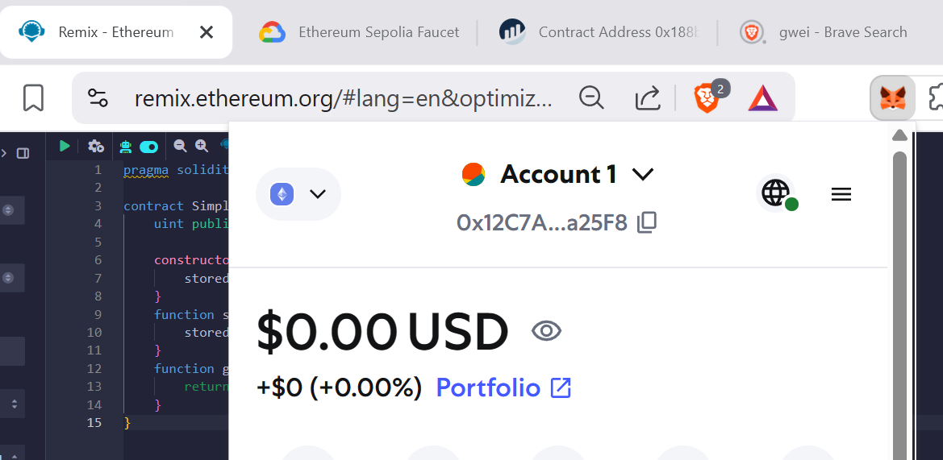

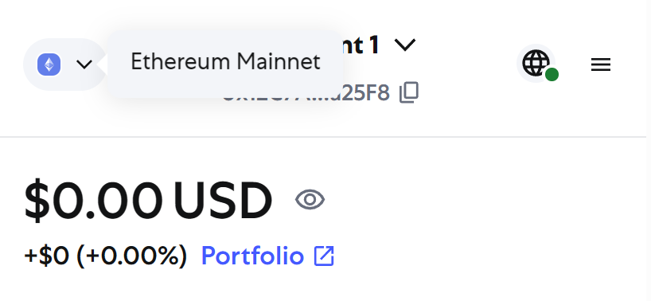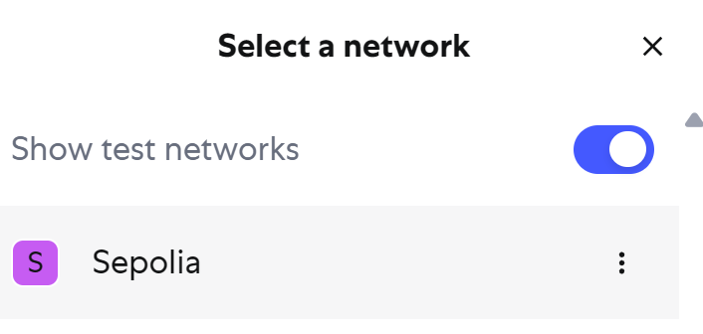

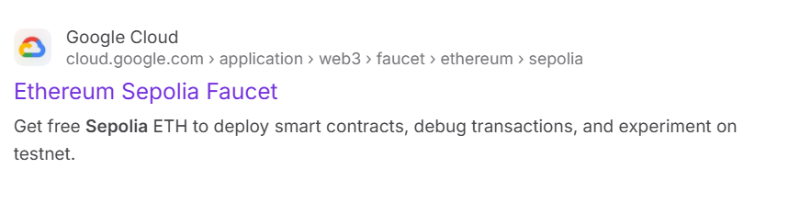

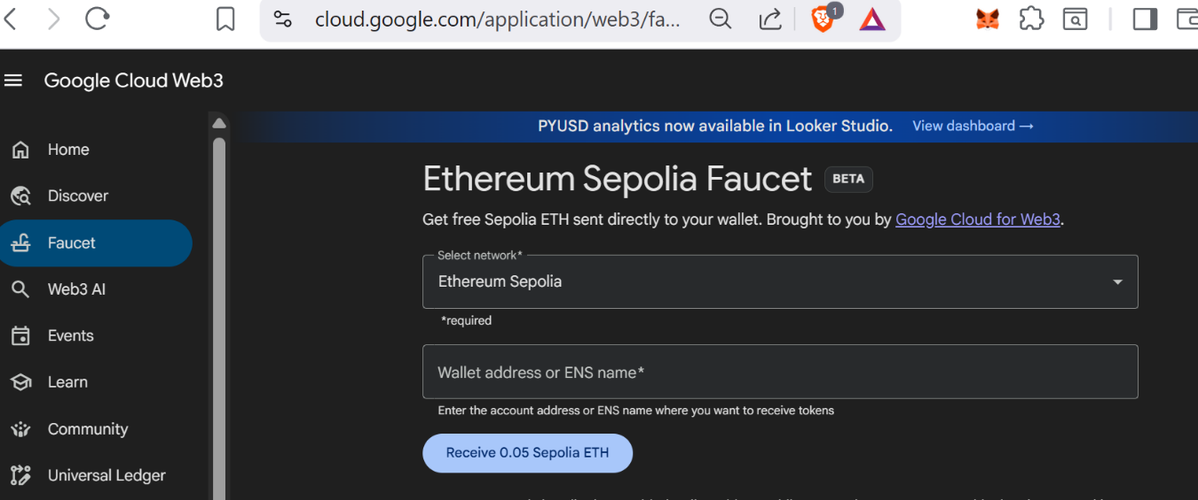

- Testing Phase: Compilation of Code(error detectection)
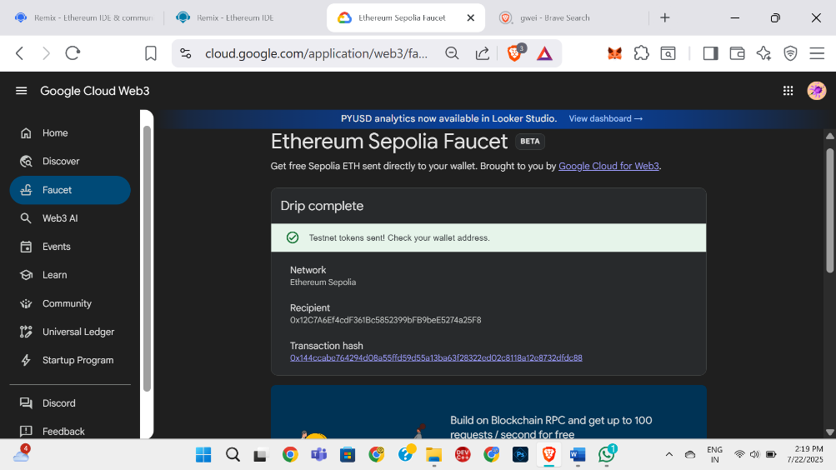

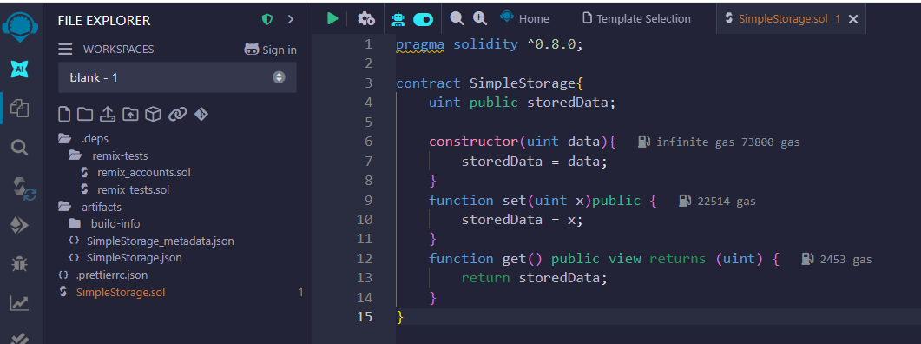

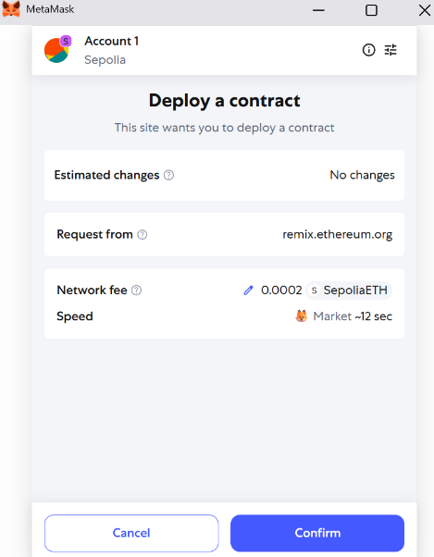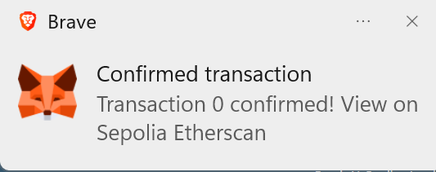

Implementation Phase: Final Output (no error)
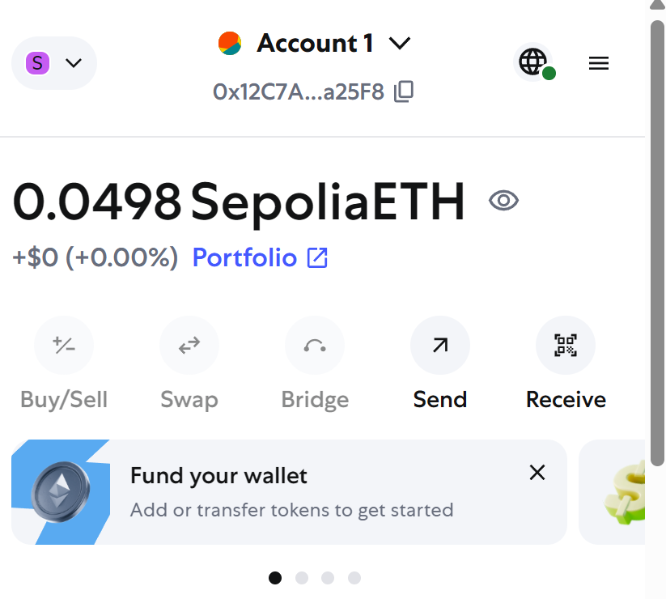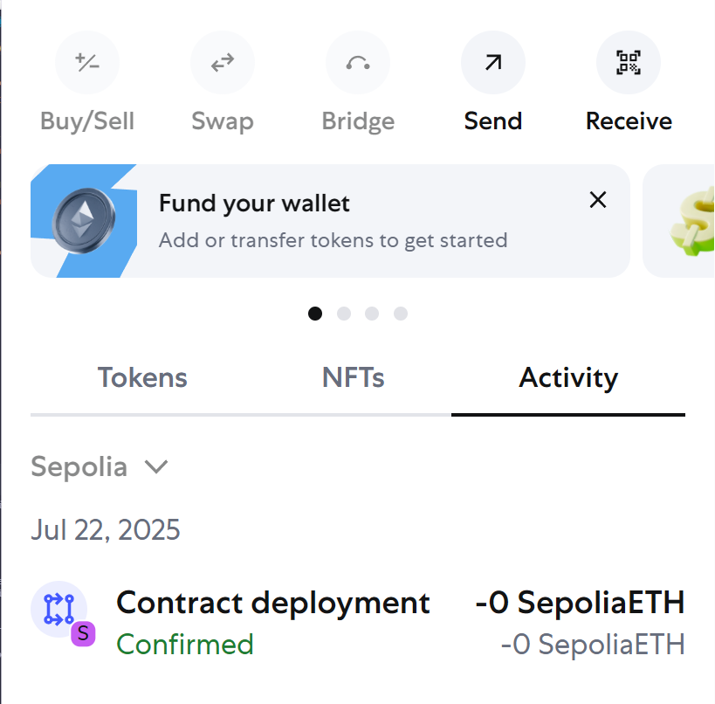

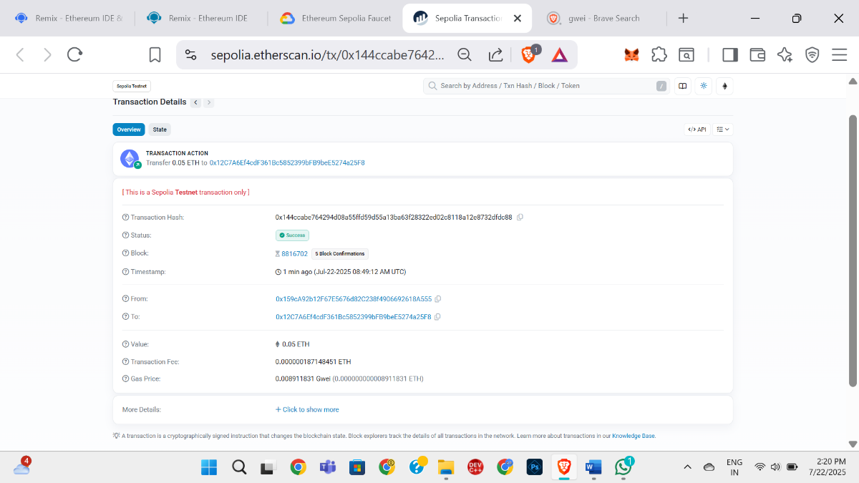

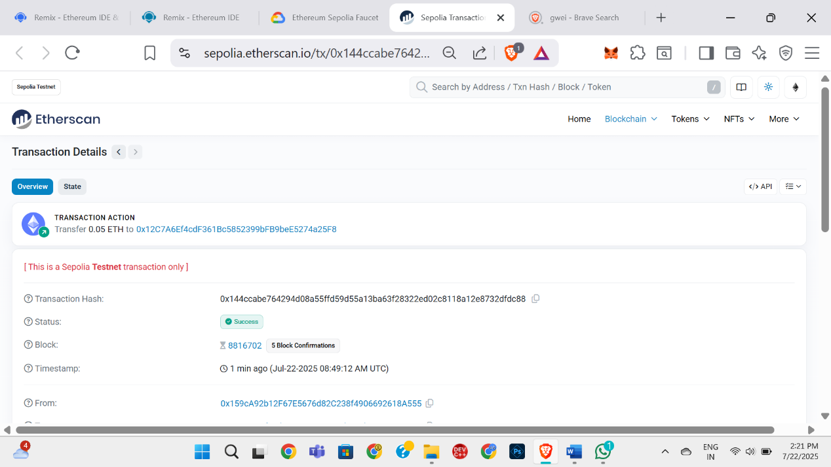

- Implementation Phase: Final Output (no error)
Applied and Action Learning

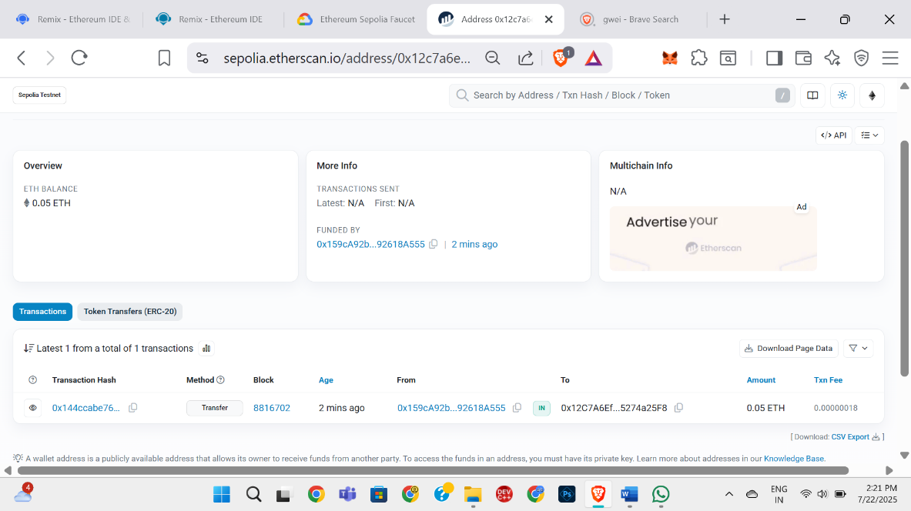

* Observations
Observations when dissecting a transaction
- You can see exactly how much gas was consumed by a specific function.
- You can confirm whether the transaction reached the intended smart contract and executed correctly.
- You can detect errors or reverts and find which part of the execution caused it.
- You can verify that events were emitted with the correct data.
- You can spot unnecessary gas consumption (useful for optimization).
- You can prove who executed the transaction and when.

ASSESMENT

Rubrics
Concept | 10
Planning and Execution/  Practical Simulation/ Programming | 10
Result and Interpretation | 10
Record of Applied and Action Learning | 10
Viva | 10
Total | 50


Signature of the Student: PN Archana
Signature of the Faculty:

